General tips for the Task below.
Task Title
AWS- Simple Queue Services (SQS) and Managed broker services (MQS)
Objective
Worked on pre-requisite, as I performed R&D on the AWS-Simple Queue Service (SQS) and Managed broker service (MQ) posted in DevOps group in slack as a requirement and task to work on Use cases, architecture flow and execution steps
Prerequisites
List all requirements before starting:
- AWS-Simple Queue Service (SQS)
- AWS- Managed message broker service (MQ)
Issues Faced: Briefly mention issues and how you fixed them. Posted below in the last.
Conclusion
Conclusion has been provided for every task at the end.

Introduction:
AWS offers various messaging services between different parts of an application so that distributed systems improve scalability and reliability.
AWS provides two main messaging services. They are:
- AWS SQS- A fully managed queue service for message decoupling.
- AWS MQ- Managed message broker service for Traditional applications.

What is SQS?
Amazon Simple Queue Service is a fully managed message queue used to send, store and read messages without losing them.
- One service sends messages (producer)
- Another service receives messages (consumer)
- They don’t talk directly to each other
- Consumer reads the messages and deletes the messages once read.
AWS handles scaling, durability, retries, and availability.

Use Case Scenario:
Task - Create a SQS Queue, send and receive messages.
Objective:
The objective of this task is to create a message, send the message to the Queue and read messages and delete them.

Prerequisites:
- Simple Queue Service (SQS)

Step by step Implementation:
Step 1: Navigate to Simple Queue Service and create a Queue.

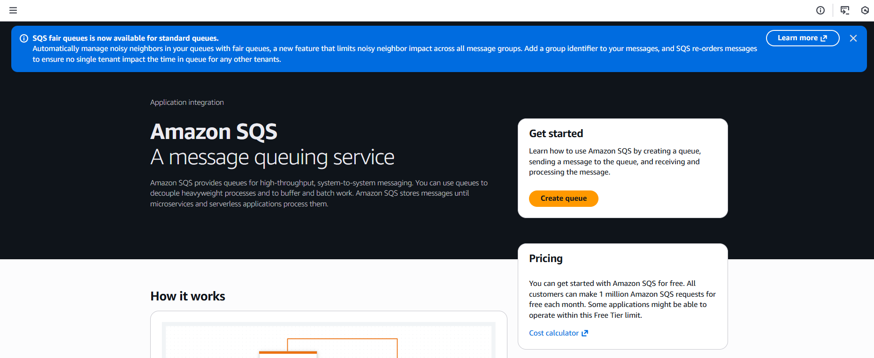

Step 2: Type shall be standard
- Name- MyQueue
- Configurations are default
- Let’s create a Queue.
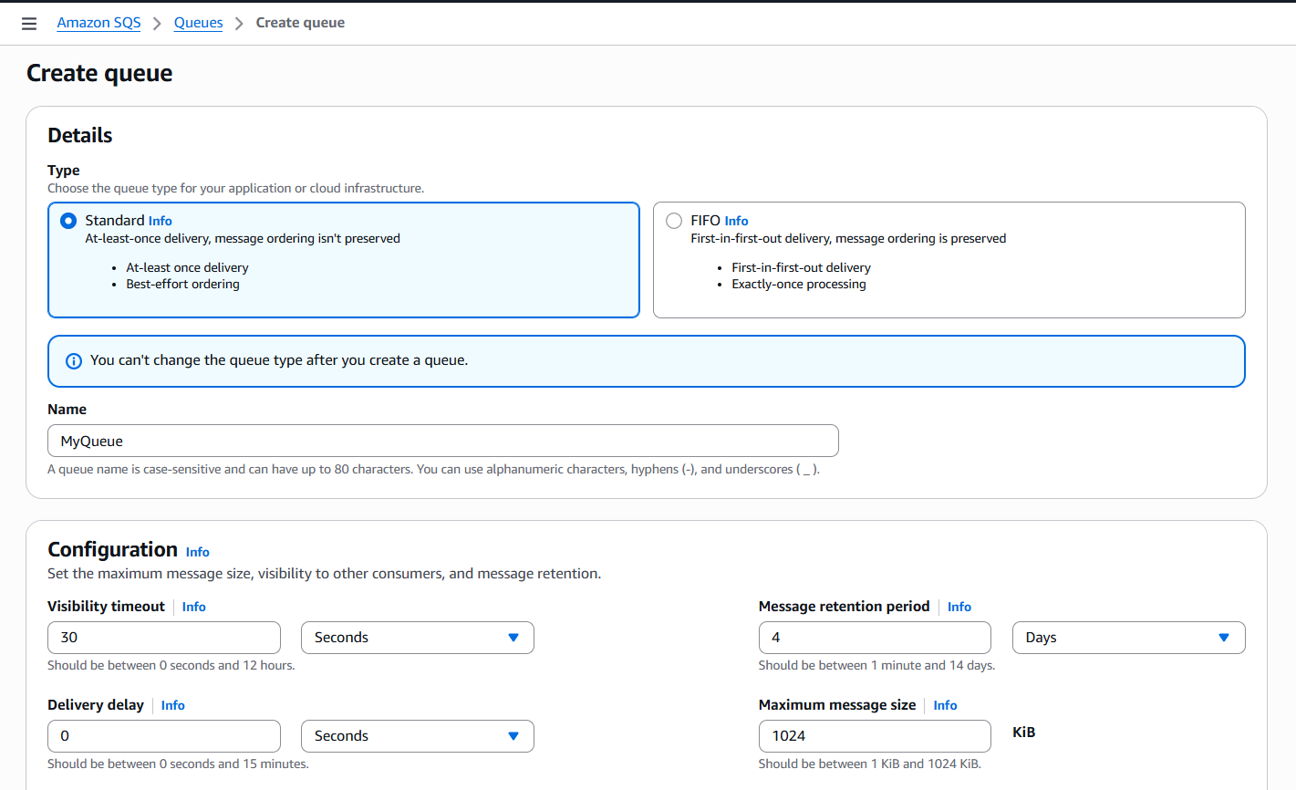

Step 3: Queue is created and MyQueue open the page automatically.
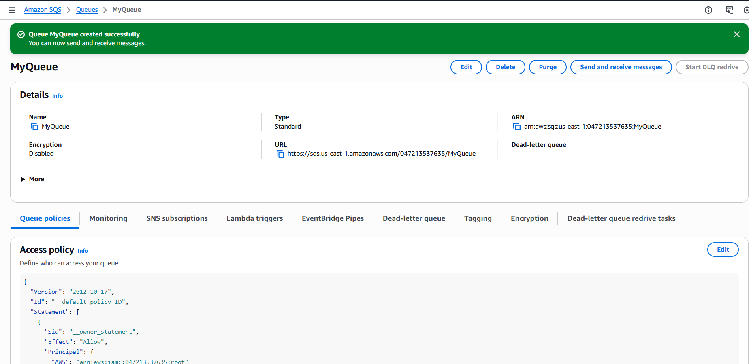

Step 5: Let’s send and receive message in lesser required timeframe.
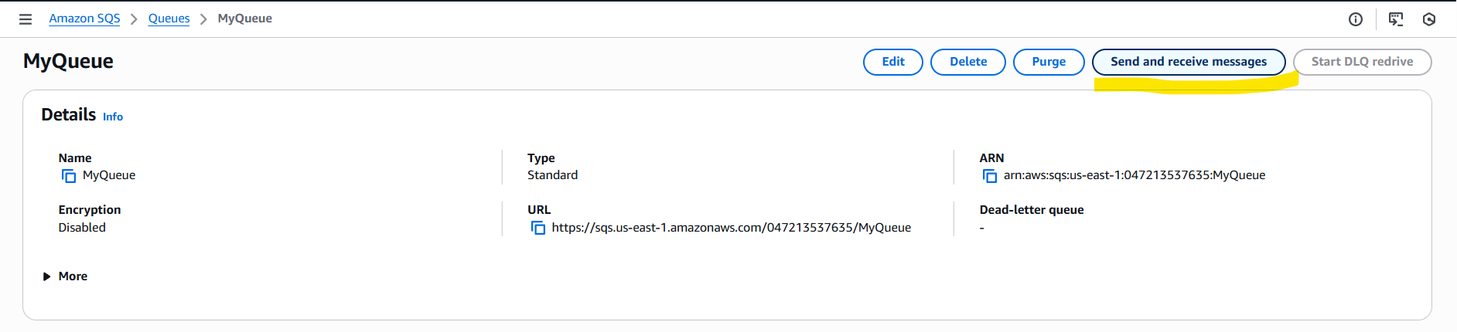

Step 6: Updated the message and sending to the receiver.
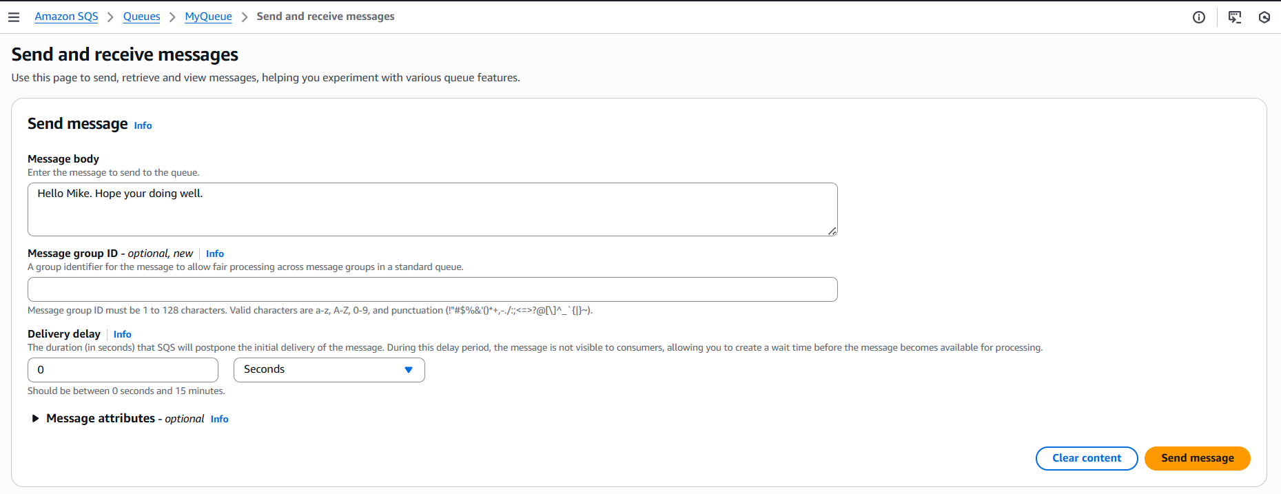

- Message sent and we need to poll for messages to receive the message.
- If Group ID was provided, the specific user/ entity will receive the message and they need to poll for messages to receive them.
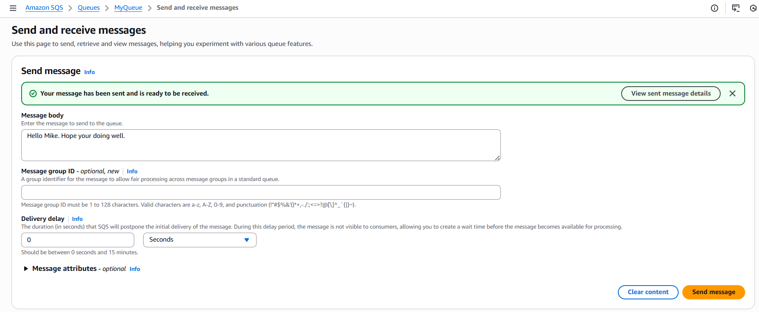
- Currently the polling is running on the backend to receive the message.
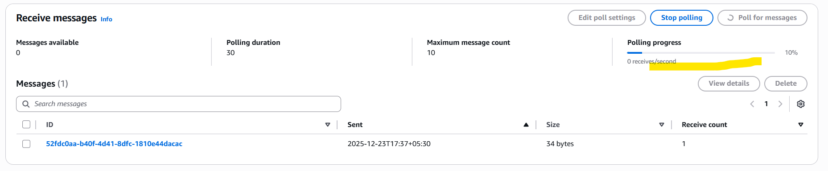

Step 7: Successfully, we received the message as I am the producer and the receiver as well.
There was no queue duration provided, so we received within seconds when polled.
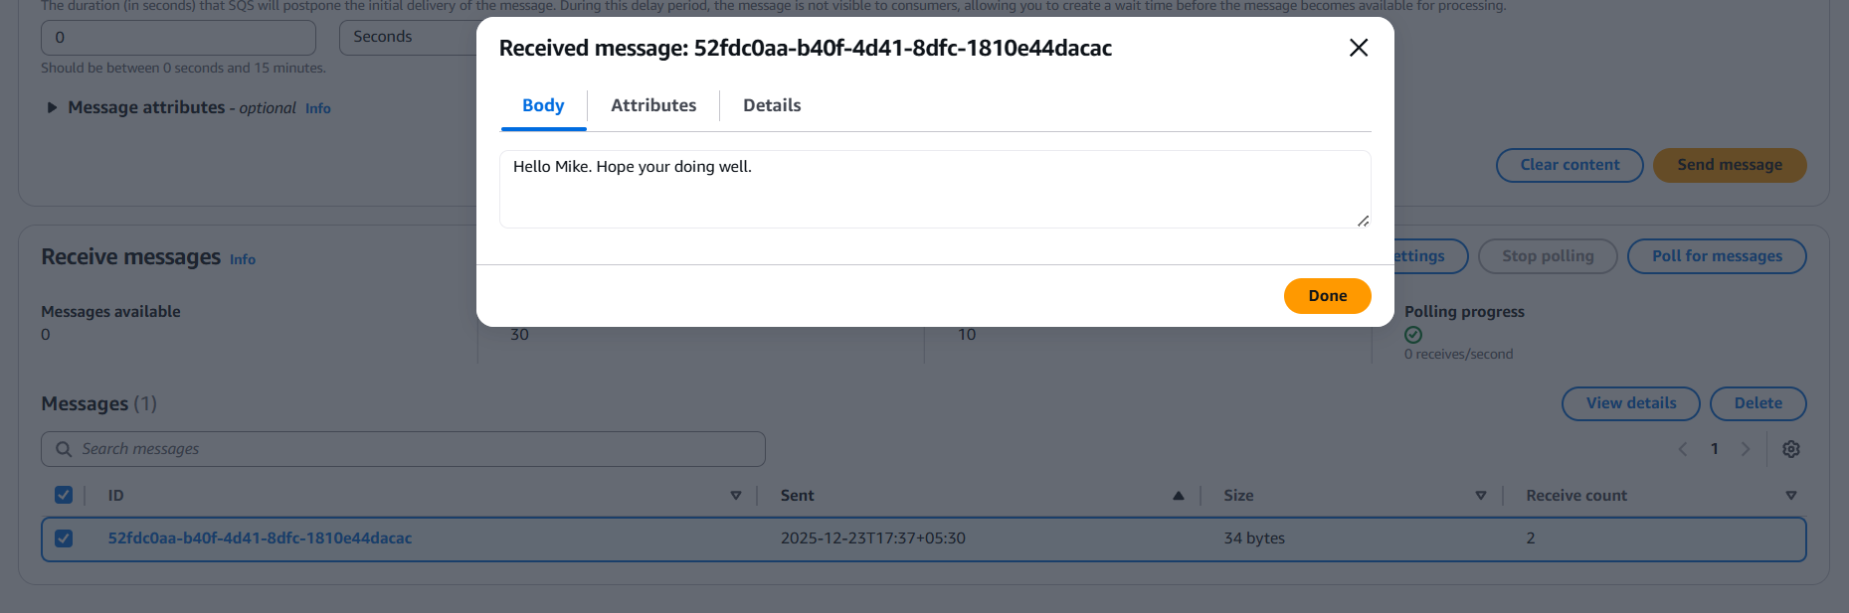

AWS SQS Architecture Flow Diagram:

Producer

SQS Queue

Consumer

- Producer sends message to SQS
- SQS stores message durably
- Consumer polls the queue
- Message processed and deleted

AWS Managed Message Broker Service (MQ)

What is managed message broker service?
Ans. AWS MQ is a managed message broker service used for applications who use traditional messaging protocols.
Applications like:
- ActiveMQ
- RabbitMQ

🔹 What is a Messaging Broker?
A messaging broker is an intermediary that:
- Routes messages
- Applies rules (topics, routing keys)
- Supports complex messaging patterns
In AWS, this is commonly done using Amazon MQ.

🔹 How Messaging Brokers Work
- Producer sends message to broker
- Broker decides where to route the message
- Consumers subscribe to topics/queues
- Messages delivered based on rules

🔹 Use Cases:
- Suitable for event-driven architectures
- complex messaging patterns.
- Migrating legacy messaging systems
- Applications using JMS, AMQP
- Complex routing and pub/sub models

Architecture Flow (Amazon MQ)

Producer

Amazon MQ Broker

Consumer

- Producer connects to broker
- Message published to queue/topic
- Broker routes message
- Consumer receives message

Task- Create a broker, send a message and verify if broker routes message and verify if message is received.
Prerequisites:
- Amazon MQ
Step by step Implementation:
Step 1: Navigate to Amazon MQ and create a broker
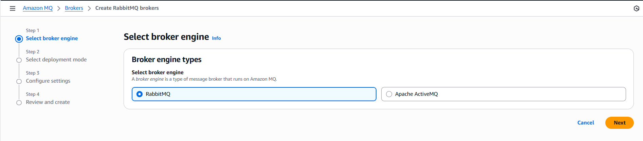

Step 2: Selected Cluster deployment because I want “Three single-instance brokers connected in a mesh network across multiple Availability Zones.
- Use for production workloads that require high availability and message durability”.
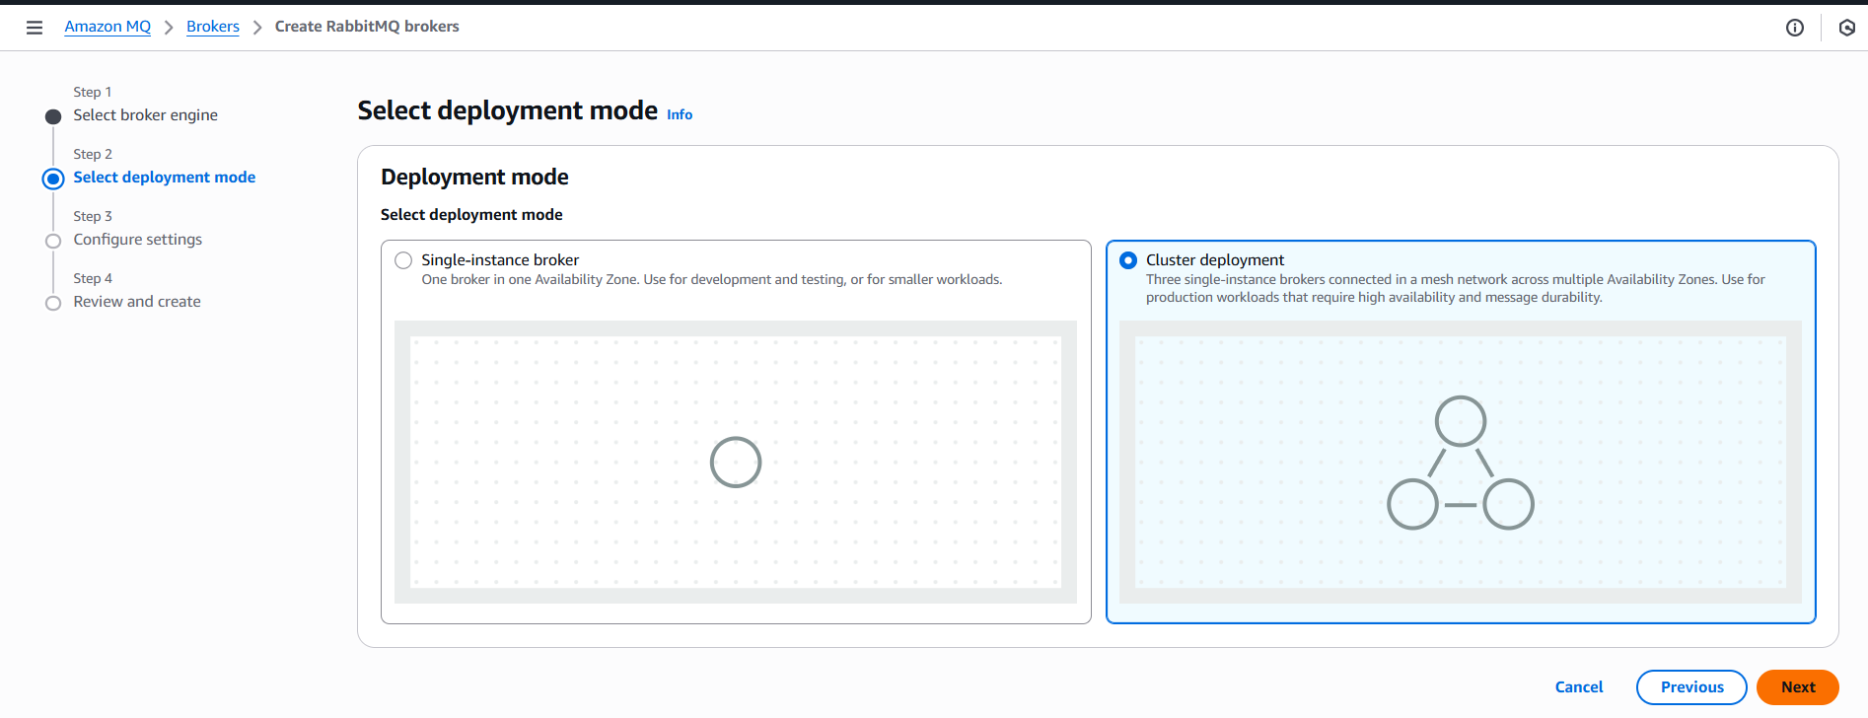
Step 3: Create a broker name and instance type is default.
- Username and Password provided as well.
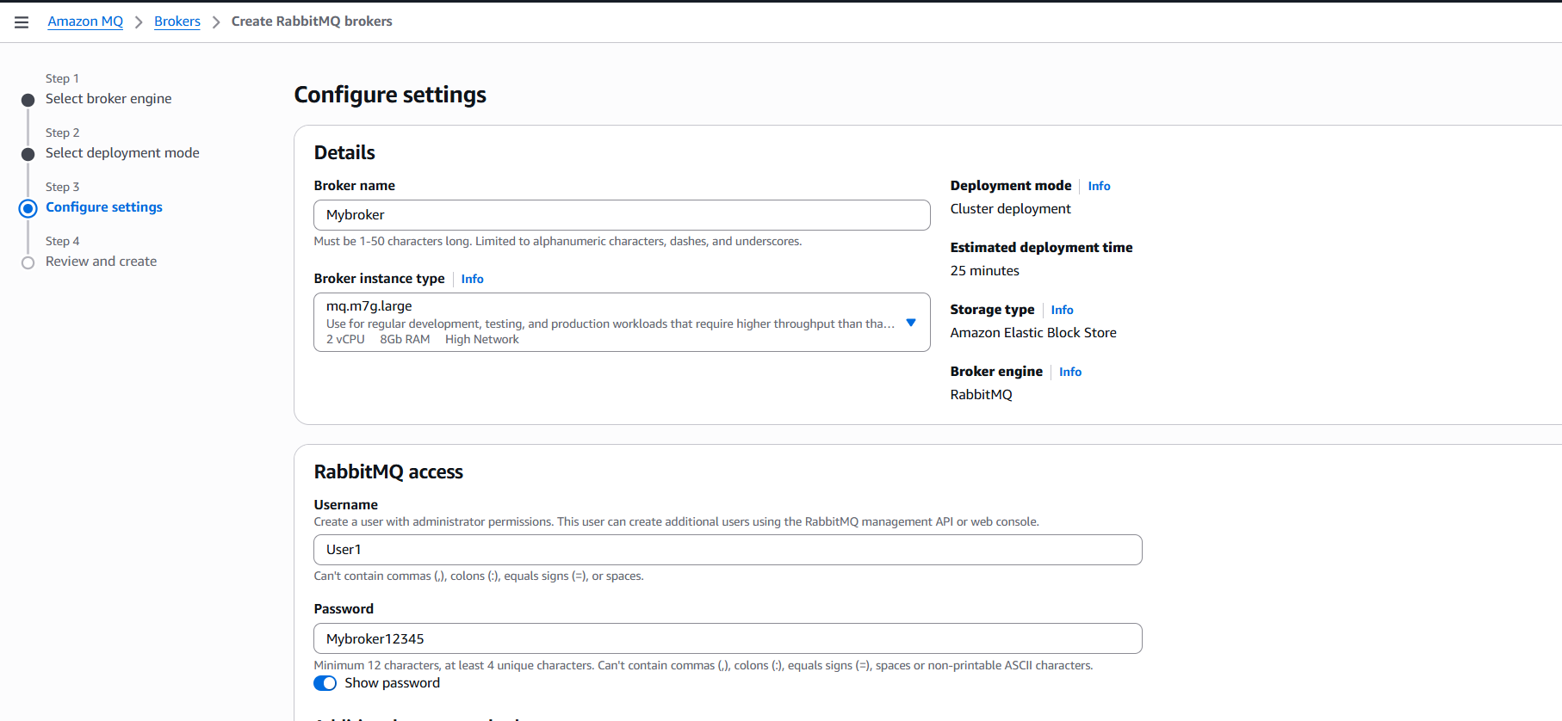
- Let’s review and create broker.
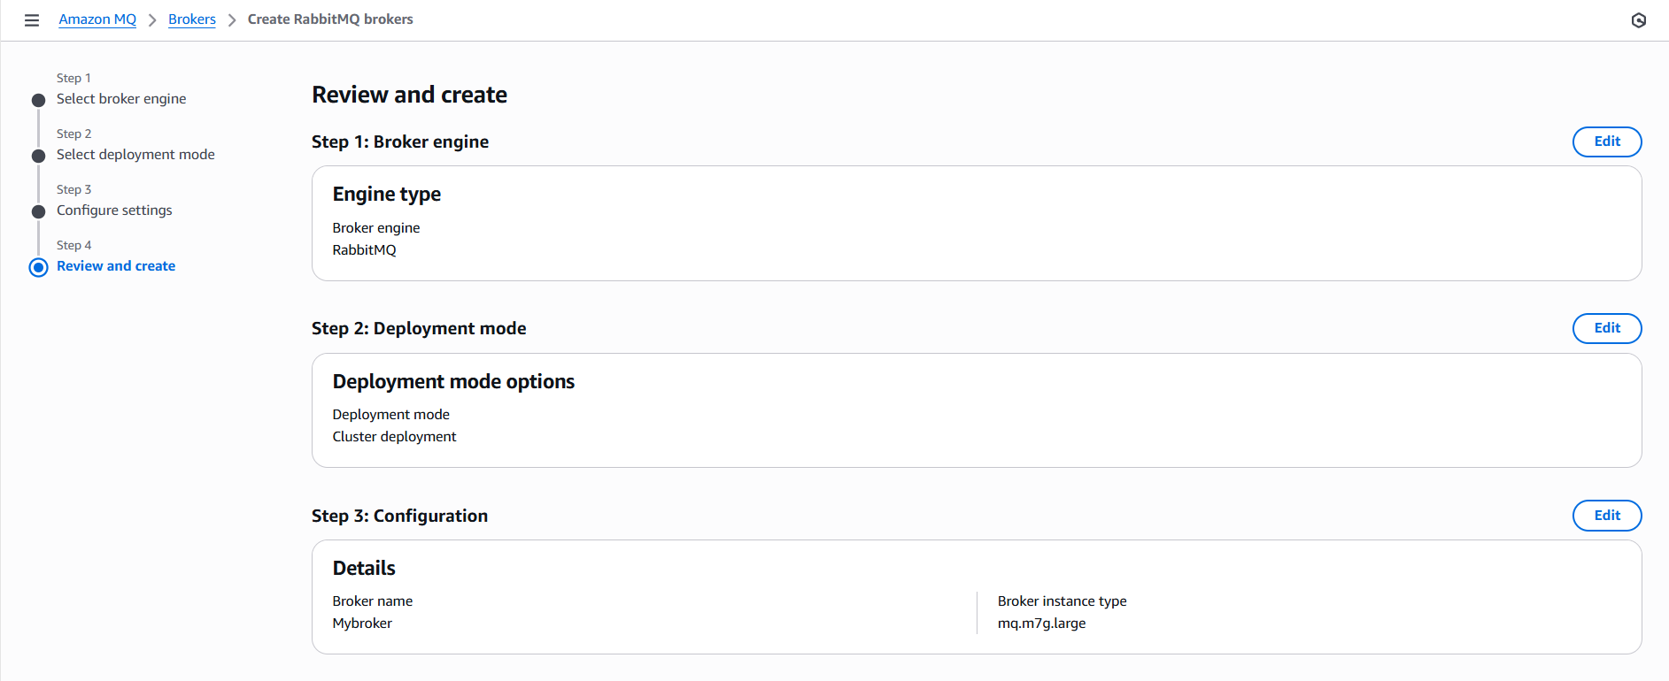

- The notification says it takes 25 minutes to deploy to create the broker.
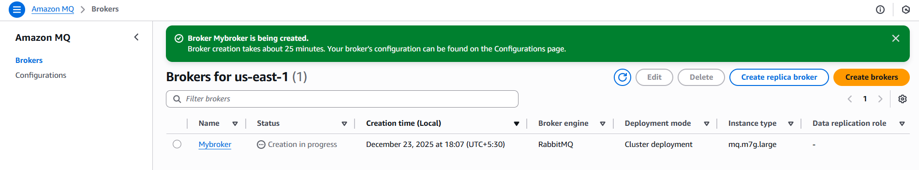
- Finally, we can see the broker is created.
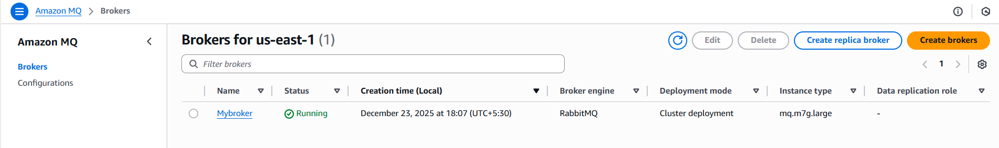
Step 4: Go into the broker and navigate to the RabbitMQ web console.
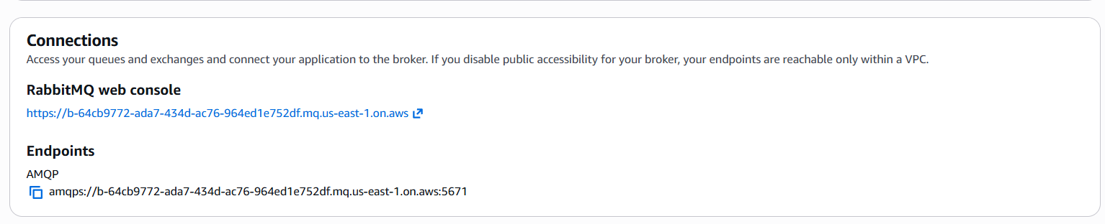

Step 5: Login using the credentials created for broker.
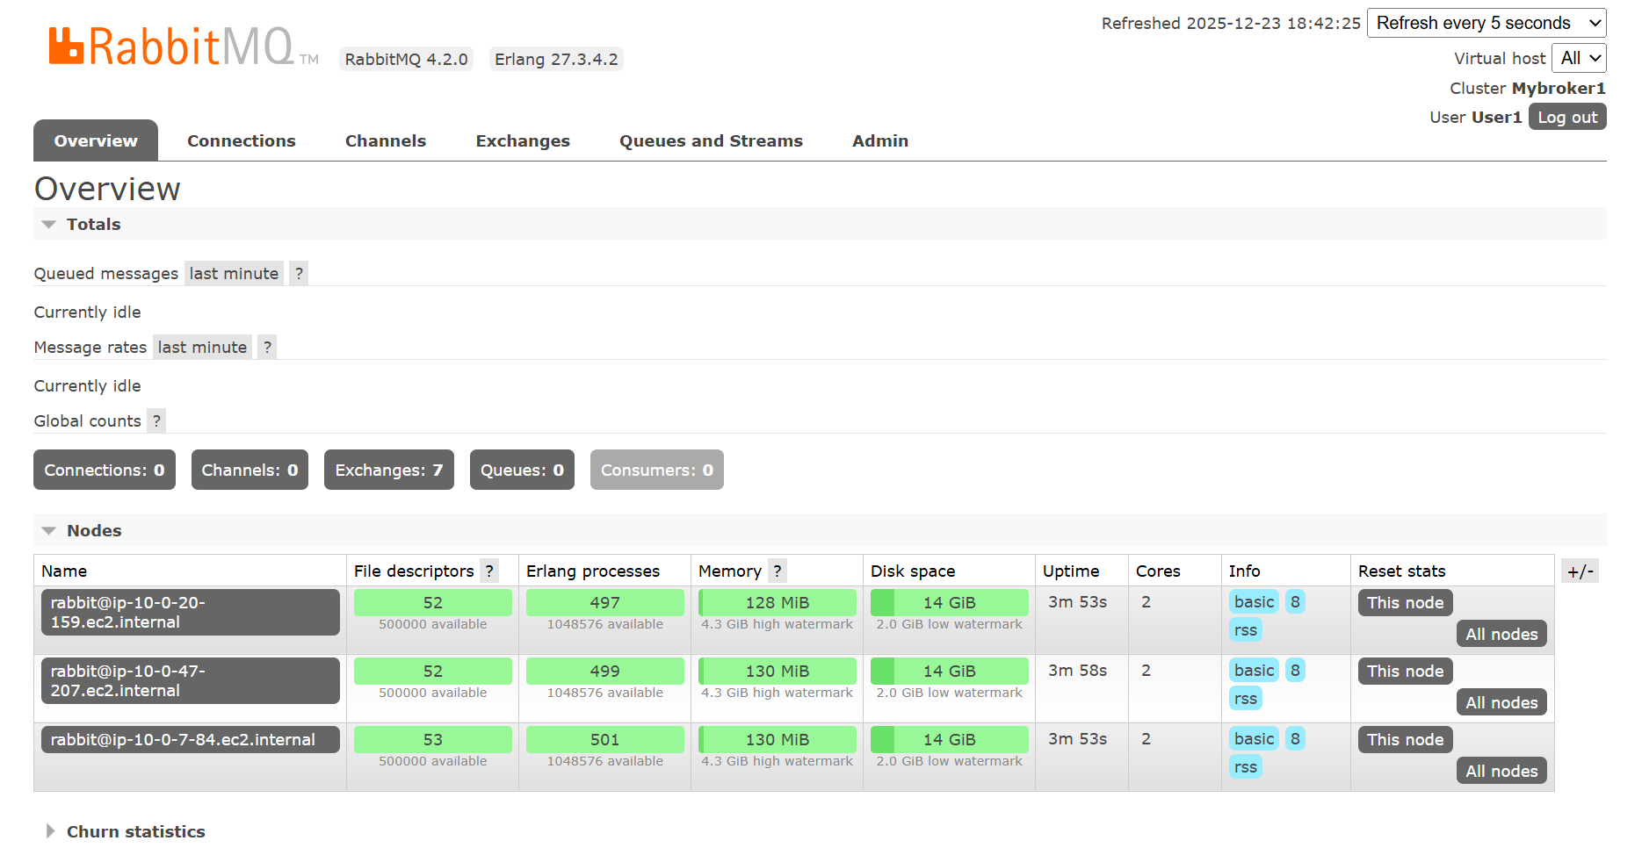

Success- We can login to the RabbitMQ, from here, Broker decides where to route the message
The customers should subscribe to the queues and they will get messages delivered as per rules applied.

Feature | Amazon Simple Queue Service (SQS) | Amazon MQ (MQ)
What it is | Fully managed queue service | Fully managed message broker
Setup | Very easy, no broker management | Needs broker setup & configuration
Protocols | AWS native API only | Standard protocols (JMS, AMQP, MQTT, STOMP)
Message order | FIFO (optional) | Guaranteed (broker-based)
Scalability | Auto-scales automatically | Limited by broker size
Maintenance | No maintenance | Broker patching & scaling required
Best for | Cloud-native AWS apps | Legacy or enterprise apps
Cost | Pay per request (cheap) | Instance-based (costlier)

